UASD Workflows – Bridger Latitude FVR-90
  - Interagency Fire Call-When-Needed Type 1 Unmanned Aircraft System
  - 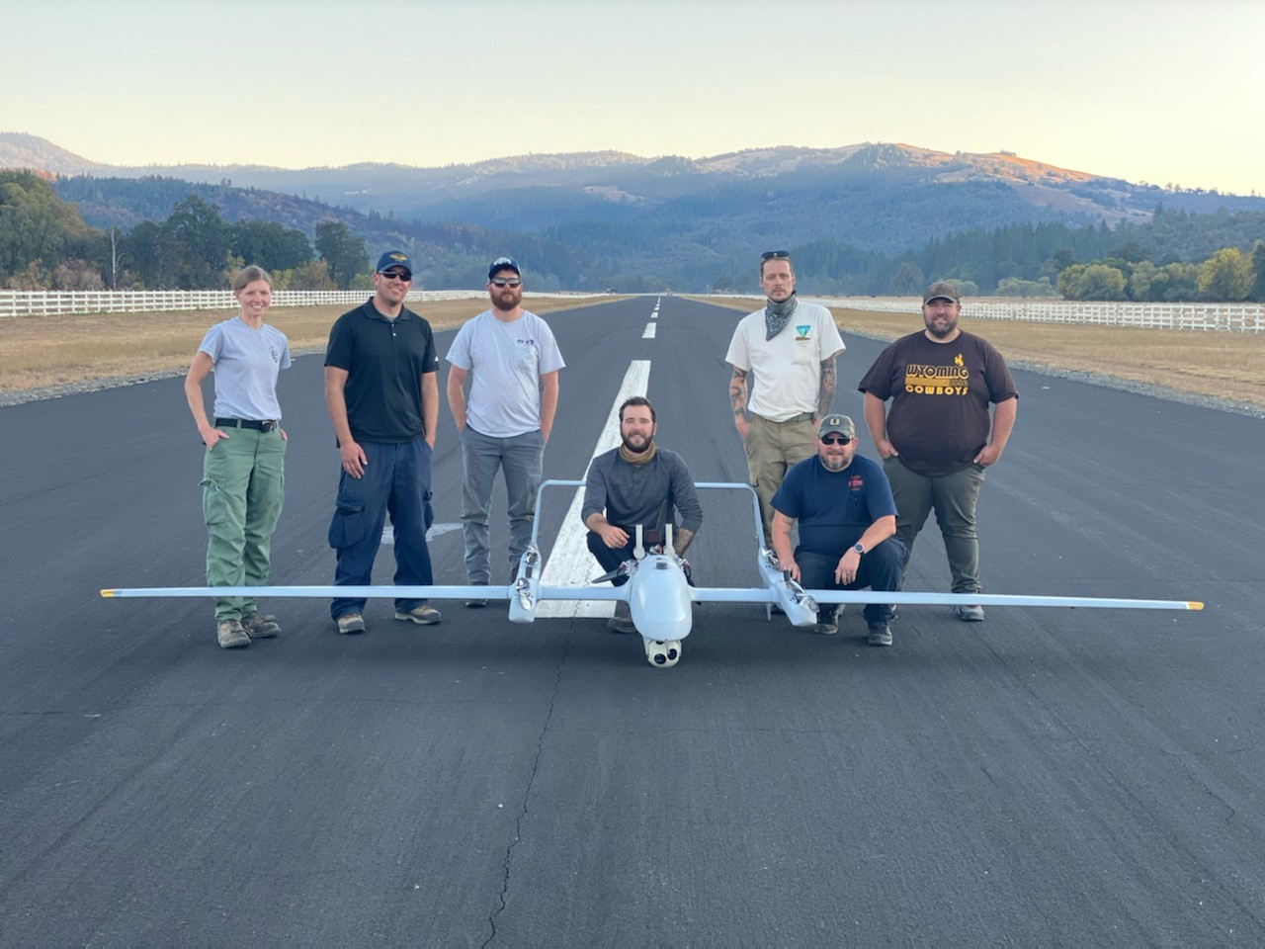
Bridger Latitude and IFUAS crew with aircraft, August Complex South Zone, October 2020

Summary
Previous summaries related to Bridger Aerospace UAS outline specs, capabilities, what the UASD did, and how well it worked. This document outlines how to complete each step of the process, as well as introduces new processes/tools.

Tasks
The following discussion builds upon previously documented workflows. Below are the main topics:
- Data Management
- Data Acquisition
- Data Creation
- Data Sharing

Data Management
Summary: Prior to assignment, familiarize yourself with or review the data structures and workflows.

NWCG GISS
- Familiarize yourself with GISS workflows:
  - NWCG Standards for Geospatial Operations, PMS 936
  - NWCG GISS Workflow, PMS 936-1
  - Download the current NWCG GeoOps folder structure
- NIFC AGOL
  - Gain access to NIFC AGOL account with GISS permissions to access data
  - Join the NIFC AGOL GeoNet Wildfire Response GIS group to download various tools
- NIFC FTP
  - Create NAP account to post items to NIFC FTP
  - Verify access to necessary GACC folder
  - Install FTP Client (WinSCP, FileZilla)

NWCG UASD
- Review the BLM UASD Toolbox
  - Download the UASD Folder Structure
  - Download any tools, software
- Review Vendor folder and Incident Summaries

Data Acquisition

Base data
Summary: At the start of each incident, base data including ownership, hydro, roads, annotations/labels should be collected for GCS base maps. There are multiple options for downloading data
- Issues
  - Non-GISS, non-USFS not familiar with USFS base data
    - Solution
      - Request base data copy to hard drive from GISS or see below
  - Encountered privacy concerns when asking IMT for certain datasets (structures)
    - Solution
      - Provide base data needs with justification as a list to AODB/SITL prior to arrival

Workflow
- NIFC AGOL GeoNet - Base Data Download Tools
  - Base Data Acquisition Tool post
  - Carl Beyerhelm GISS widgets post
  - USFS Data National Base Map post
- Sensitive Data requests
  - See items and justification document here

Data Creation

Launch and Recovery Zone (LRZ) analysis
Summary: After gathering a list of LRZ coordinates, add all LRZ to a feature class and use a batched process to avoid task repetition.

Workflow
- Follow workflow posted on BLM IFUAS UASD Toolbox site
- Run Python script to automate/batch LRZ analysis
  - Inputs:
    - 1 NM radius

Ground Control Station - Vexos and Piccolo map creation

Workflow

CartoType map generation
Summary: At the start of each assignment, the vendors download a CartoType CTM1 file package containing OpenStreetMap and USGS height (DEM) data, which is displayed on the Vexos GCS map.
- Issue:
  - TIFF data exported from Map view in ArcPro no longer allows control over DPI output
  - Solution
    - Export data as PNG with world files
- Issue:
  - To add the daily fire event data, previously UASD needed to create base maps as PNG/TIFF to share with vendors, which the vendors then uploaded via internet to convert the PNG to a CTM1.
  - Solution
    - This CartoType workflow negates the need for internet connection after the vendor downloads a base CTM1 file.

Piccolo perimeter file
Summary: At the start of each operational period for the UAS, a line shapefile should be transferred from a jump drive to the vendor’s Piccolo laptop for viewing with Piccolo flight plan waypoints.
- Issue:
  - Piccolo does not accept polygons well
    - Solution
- Downloaded IR Heat Perimeter .shp from most recent IR data
- Run Polygon to Line tool to create .shp file
- Verify Geographic Coordinate System as WGS84

Situational Awareness Products
Summary: Both Incident Management Teams wanted static images which showed the IR or EO image of the point of interest (e.g., hotspot, structure), along with a map, coordinates, scale, distances, etc.). Powerpoint images were initially created, then images were created using Map Series in ArcPro.
- Issue
  - Using Powerpoint was time consuming and inefficient for redundant data entry
  - Solution:
    - Map Series layout template creation in ArcPro UAS Pro Project Template

Workflow

ArcGIS Online Web Feature Service/Feature Class with attachments enabled
Summary: Following a workflow similar to NWCG GISS Wokflow, use existing UAS Web Feature Service (WFS) template for either downloading a local copy or creating an incident specific Web Feature Service (WFS) to AGOL. Creating a feature allows for easy editing, tracking of hotspots, verification of coordinates, and product creation. This step is meant to be done in succession with Data Creation - Static Images.
- UAS WFS Creation
  - Schema
    - Utilize UAS WFS Template on UASD Group or follow Local Copy GISS workflow
  - Sharing
    - If using AGOL WFS, see Data Sharing - AGOL for how to share with IMT GISS
- UAS WFS Editing
  - Set Up: In ArcPro (optional but makes it easier to find and edit quickly)
    - Add to UAS WFS to Portal favorites
    - Add to Create Features favorites
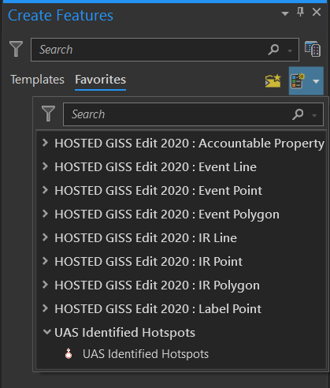
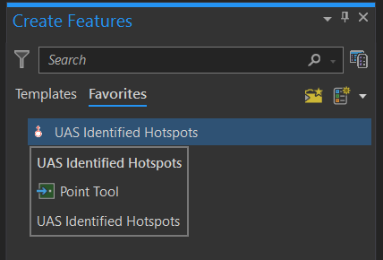

- Editing:
  - Using template from Create Features, right click on Map View, 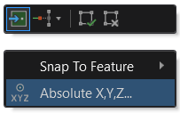
  - Enter coordinates, changing format if necessary
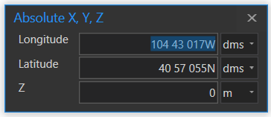
  - Calculate Lat/Long in attribute table to show up in labels or dynamic text for Map Series
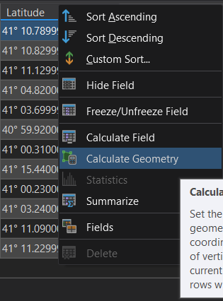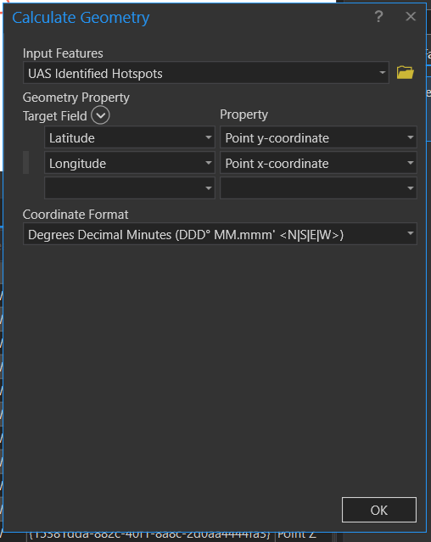

  - Populate attributes
  - Save Edits in WFS
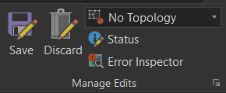
- Attachments
  - Ensure “Enable attachments” is set up in GDB – Should be if downloaded from template
  - Attach photos from Full Motion Video – Images step

Full Motion Video - Images
Summary: Use UDP Port and ethernet cord for physical connection to livestream gimbaled EO/IR sensor data from aircraft to Full Motion Video in ArcPro. Telemetry data is not displayed on the ArcPro FMV video player image, though North Arrow can be displayed. Images are captured while features are created from WFS. This step is done in succession with Data Creation - ArcGIS Online Web Feature Service/Feature Class with attachments enabled. This live feed is used to create archived video, screen recording, chipped images (displayed as georeferenced images in Arc or as static images in Windows Media Player) that are also used in Data Creation - Static Images.
- Issue
  - UDP port utilizes closed port on DOI networked computers
    - Solution
      - Use BLM non-networked computers
- Set up Full Motion Video:
  - Add live feed path as follows
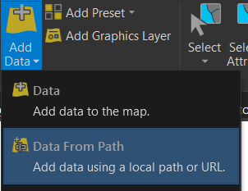
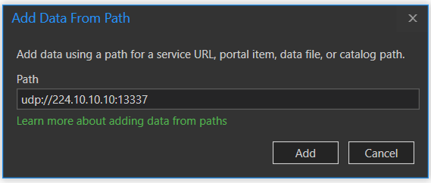

  - Change settings in Configure Workspace
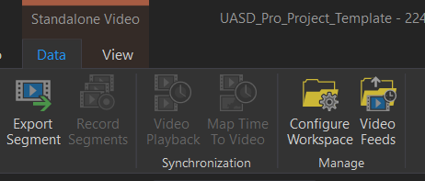

    - Can change multiple settings, but most important to change Imagery Exports from NTF to PNG
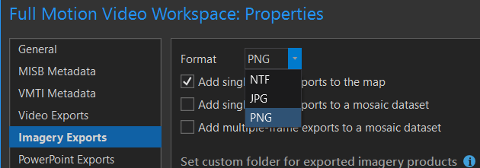

- During live-stream, when viewing point-of-interest, to save frames, click once on Frames to Images button. This will continuously save frames as long as the button appears depressed.
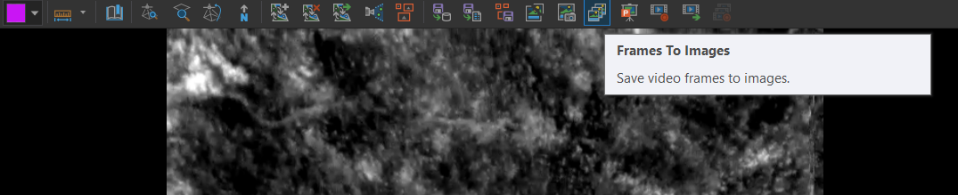
  - Save images to FMV folder with name for finding later (Saving with Division, Object ID, and description is helpful)
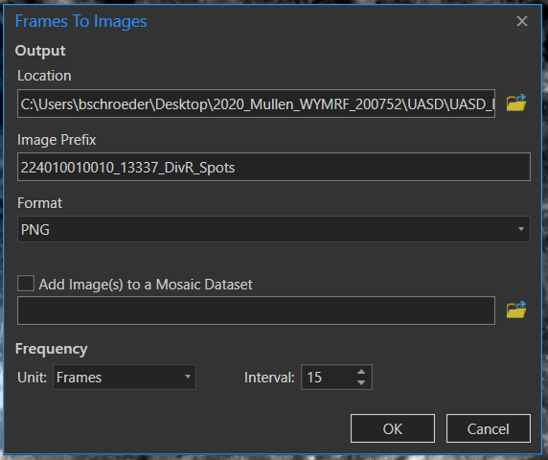
  - Once image collection seems sufficient, turn off Frames to Images button
  - Sort through folder in Windows to find best image for point of interest
  - Save chosen image along with PGW and CSV in Final Images folder
  - Attach respective photo to respective UAS WFS/Feature Class (See above)

Static Document/Image Products (PDF/PNG)
- Using UASD Pro Project Template (Copy or Save As, depending on data structure):
  - Verify correct Event data in all three Map Series maps
  - Verify correct features, lat/long populated, photos attached, and attributes completed in UAS feature data
  - In Map Series Layout:
    - Check “fake” extent indicators
      - KNOWN ERROR IN PRO: Extent indicators and graticules cannot be displayed concurrently. This will cause an error and eventually crash the project.
    - Display extent indicators as graphic instead

Mapping Products
Summary: Multiple ways of generating flight lines for mapping areas/fire perimeters, here is one documented way
- Issue: Vendor pilots are greatly assisted with mapping when flight plans are created as guides, but it is difficult to transfer Mission Planner fight plans to .shp or .kmz files
  - Solution:
    - Use UASD Python Tools

Workflow

Mission Planner inputs
- In order to make estimates based on specific shape (not an option on Fire ODS.xls)
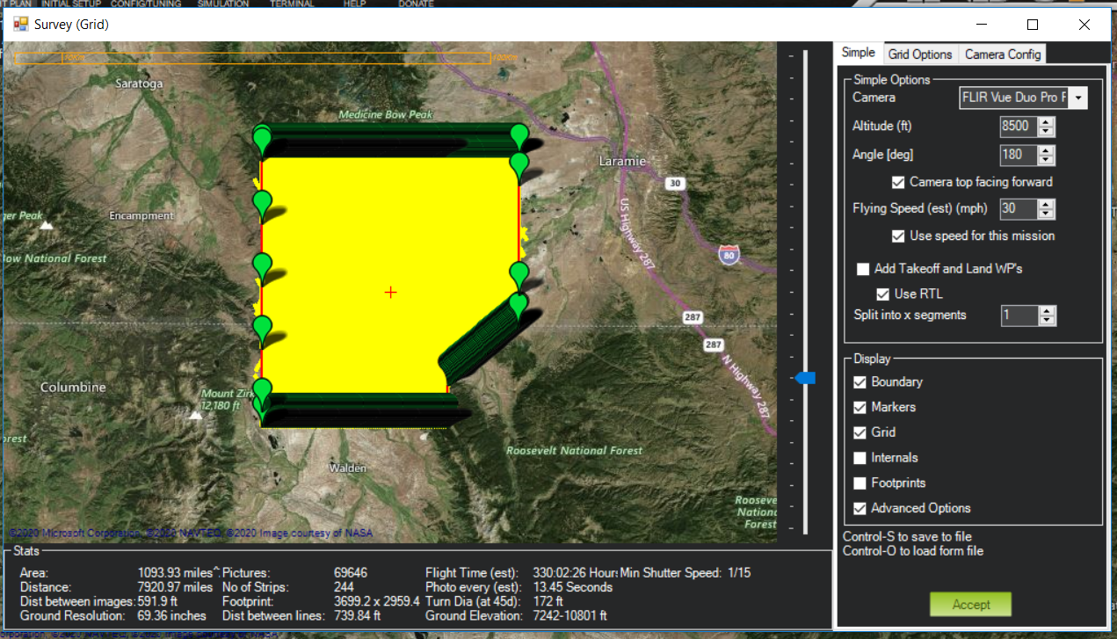
- Add IR camera config specs to Mission Planner, if not in already
  - Overlap/Sidelap
    - USGS recommends 80-90% sidelap for FLIR Duo Pro R
  - Speed
    - 30 kts (intervals will be excessive with headwind, correct with tailwind;vendor sets at 5 sec, so will need to remove photos based on calculated interval)
  - Altitude
    - Get estimated AGL (or calculate from MSL)
- Make note of footprint size and distance between flight lines

ArcGIS lines (Or use UASD Python Tools)
- In order to generate lines with correct spacing in Arc
  - Fishnet tool
    - Verify correct PCS (Web Mercator WGS84)
    - Base cell size on Mission Planner inputs
      - i.e., 225 meter by 225 meter
    - Generate as polyline, no labels
    - Mask to TFR
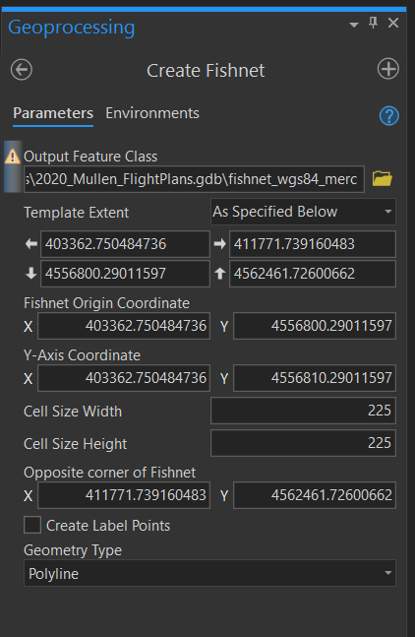
  - Copy lines, rotate based on 45 degrees, 90 degrees, 135 degrees, 180 degrees
  - Generate polygon of AOI for daily mapping objective
  - Clip to AOI
  - Export as GCS WGS84 lines for Piccolo

Agisoft Metashape
- Follow existing workflows by USGS or BLM

ArcGIS IR Data Analysis and Display
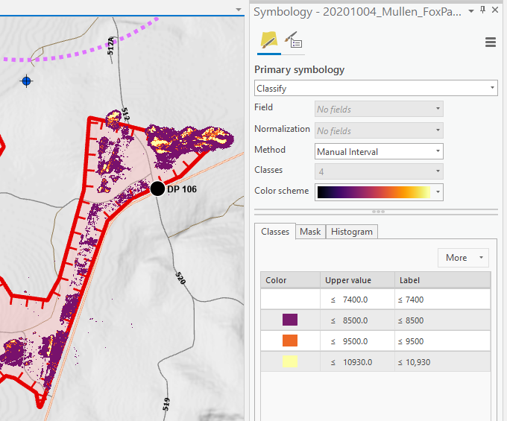
- Bring IR orthomosaic into ArcMap/Pro
  - Display Classification, Defined Interval, 2000 (since it is in Kelvins, or could do raster calculation)
  - Run Reclassify or Con Tool to generate a raster based on histogram distribution
    - Example: >7300
  - Run Raster to Polygon Tool to generate polygons of scattered heat
  - Display Layer

- Final Products
  - Vector Data
    - Export to KMZ and/or
    - Ingest in UAS WFS and/or
    - Add to NIFC Event Layer IR
  - PNG/PDF map of heat
  - IR Interpret Log
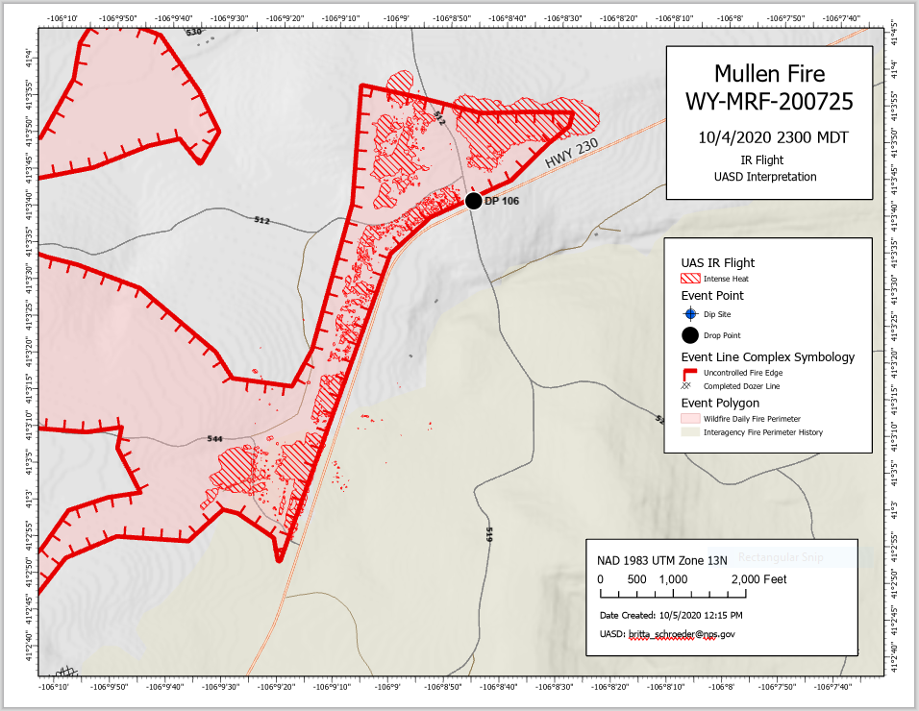

Data Sharing
Summary: Both Incident Management Teams wanted to view data in real-time, as well as have products to pass to Day or Night division

Teams/Outlook
Summary: When internet connectivity existed, Microsoft Teams/Outlook allowed UASD to share static images, Zoom information, and updates on flight status through the Chat and Files features in the appropriate Teams Channel. This worked well for both Teams, though feedback requested that we provide more background when sharing the Zoom Channel information in Teams chat.

Workflow
- Coordinated with Plans to have UASD added to Microsoft Team for IMT
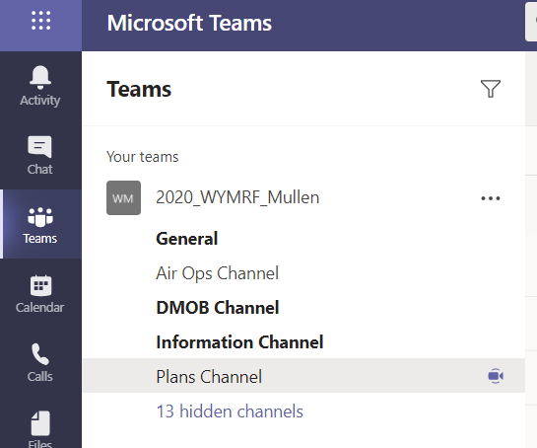
  - Created a UASD folder within Plans Channel Files
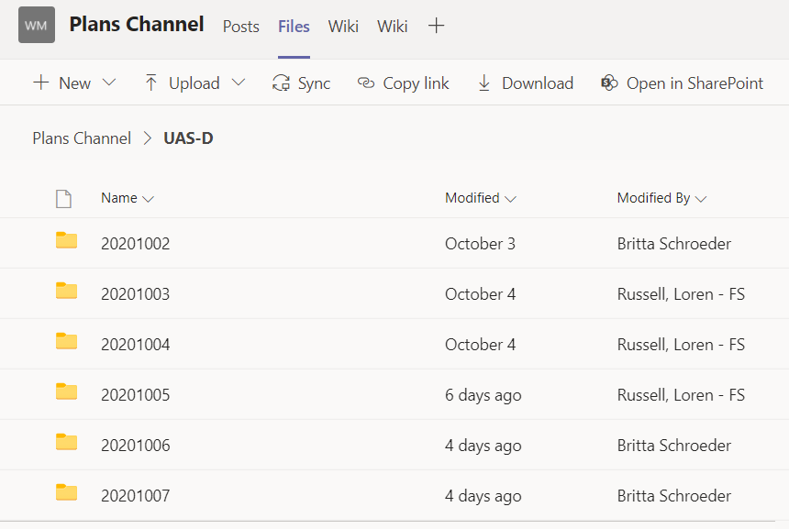
  - Posted static images to UASD folder at the end of each operational period, sharing announcement with Plans and Air Ops Channel
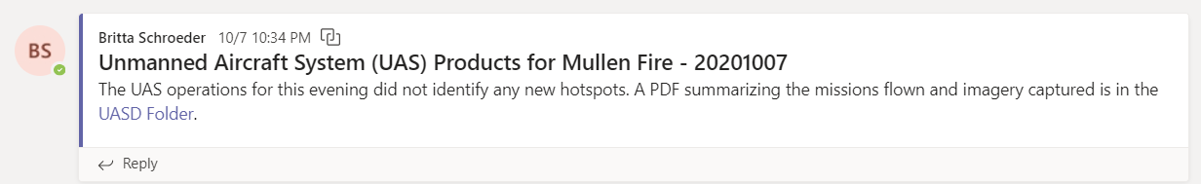

Zoom Meeting
Summary: When internet connectivity at the LRZ allowed, a Zoom meeting was initiated to allow real-time GCS screensharing with ICP or others in the field with internet connectivity. The audio and text chat also allowed the UAS module to share data or adjust flight plans to match requests from ICP.

Workflow
- Generate Zoom Meeting ID and Password each night
  - Issue:
    - Sometimes internet dropped or Vexos screen crashed; if Host ends meeting, may need to regenerate Channel ID and password
    - Solution
      - Ask participants to remain logged in to same Zoom meeting, even if host disappears, and to watch Teams Channel announcement for updated Zoom Meeting information
- Posted log-in info to Team Channels each night (Sharing with Plans, Air Ops, PIO if requested)
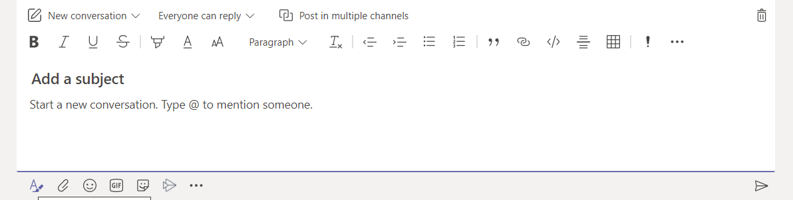
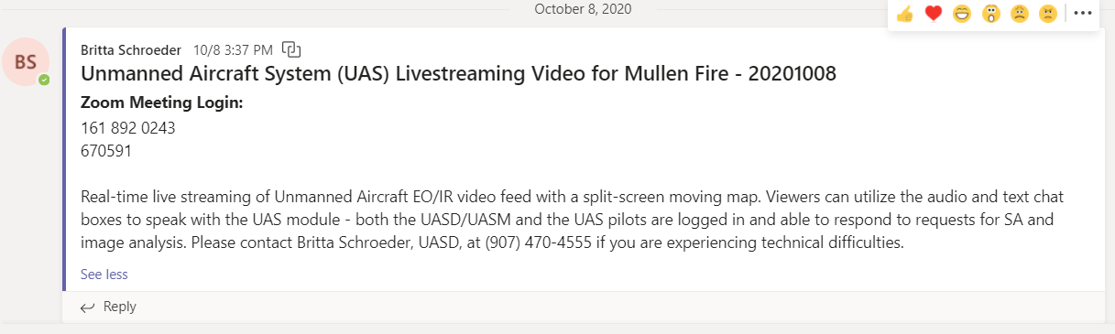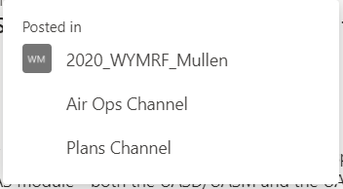
- Screenshared Vexos GCS screen; Allowed communications via audio and coordinate sharing via text chat.
  - Pros
    - Allowed vendor sensor operator to utilize pointer when describing location of points of interest to Ops/Plans viewers over Zoom audio
  - Cons
    - Vexos GCS has minimal features to keep from cluttering map
    - Sharing the vendor’s screen instead of the UASD screen did not allow for toggling on/off layers that sharing

AGOL
Summary: Air Ops with the Southern Blue Team requested a workflow utilizing AGOL data that could be transferred during the morning ops pre-briefing and used in the field the morning after a flight. Discussions with the GISS team resulted in the creation of a UAS Hotspot Web Feature Service in AGOL under the Southern Blue Team GISS Group that included photo attachments. Discussions also included how to incorporate IR polygons from orthomapping.

Workflow
- Coordinate with GISS team when creating the UAS WFS
  - To determine Owner, Group
    - If using template, UASD can create WFS for incident and share with GISS group or transfer ownership
  - To determine how UAS WFS will be queried
    - Can be queried by day in AGOL (not Pro) either in Visualization or as new Hosted Layer for using in daily Collector maps or Ops maps
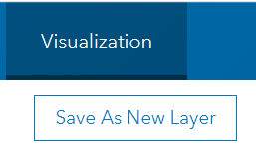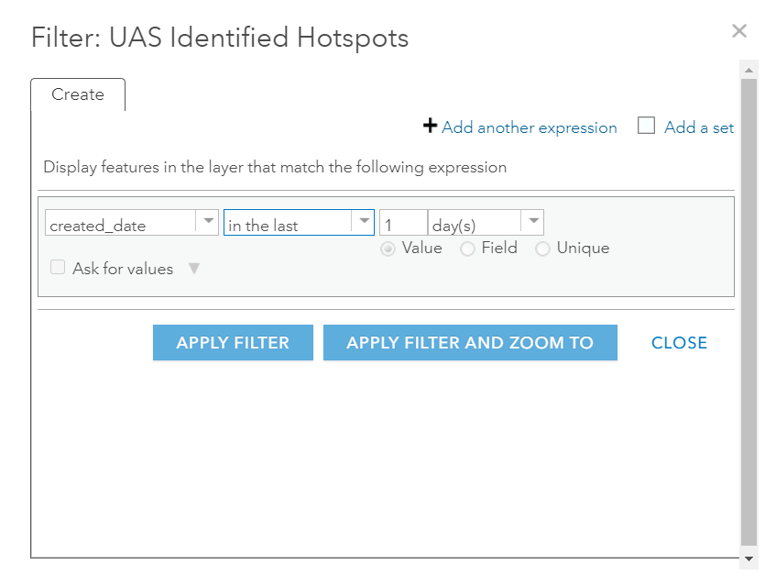
  - To determine how UAS WFS will be displayed
    - Symbology for hotspots currently matches NIFC Event Points, should be displayed with different tint
    - If previous days are not queried out, could be displayed with blue tint
  - To determine how UAS WFS will be shared with incoming Divisions (Collector?)
- Coordinate with GISS team when sharing IR polygons
  - IR polygons do not require attachments so IR polygons can be added to NIFC Event polygons

NIFC FTP Site
Summary: Air Ops with the Southern Blue Team requested sharing UAS static products and a KMZ file for use in Avenza on NIFC FTP site.

Workflow
- Work with GISS to determine repository for static products
  - Suggested:
    - /public/incident_specific_data/GACC/year/incident/intel/uas
  - Items to include:
    - Situational Awareness Products:
      - PDF or PNG of each spot with imagery (generated from Map Series)
      - GeoPDF, scaled to entire points of interest from current operational period (similar to NAIROPS product of fire)
      - KML with image pop-up for each spot
    - IR photo mapping
      - PDF of raster classification
      - KMZ of hot spots

